**Characters:-**

Unit types should be distinguishable from each other. Having some distinguishing feature (weapon, size, color, etc.) is important to keeping the action on screen manageable to understand.

Units should have a changeable color accent that communicates which player owns that unit. (as in Starcraft).

Aliens: Not too hard to find sci-fi alien models. Emphasize organic elements to differentiate from robots. Wide variety of models to represent diversity of alien species.

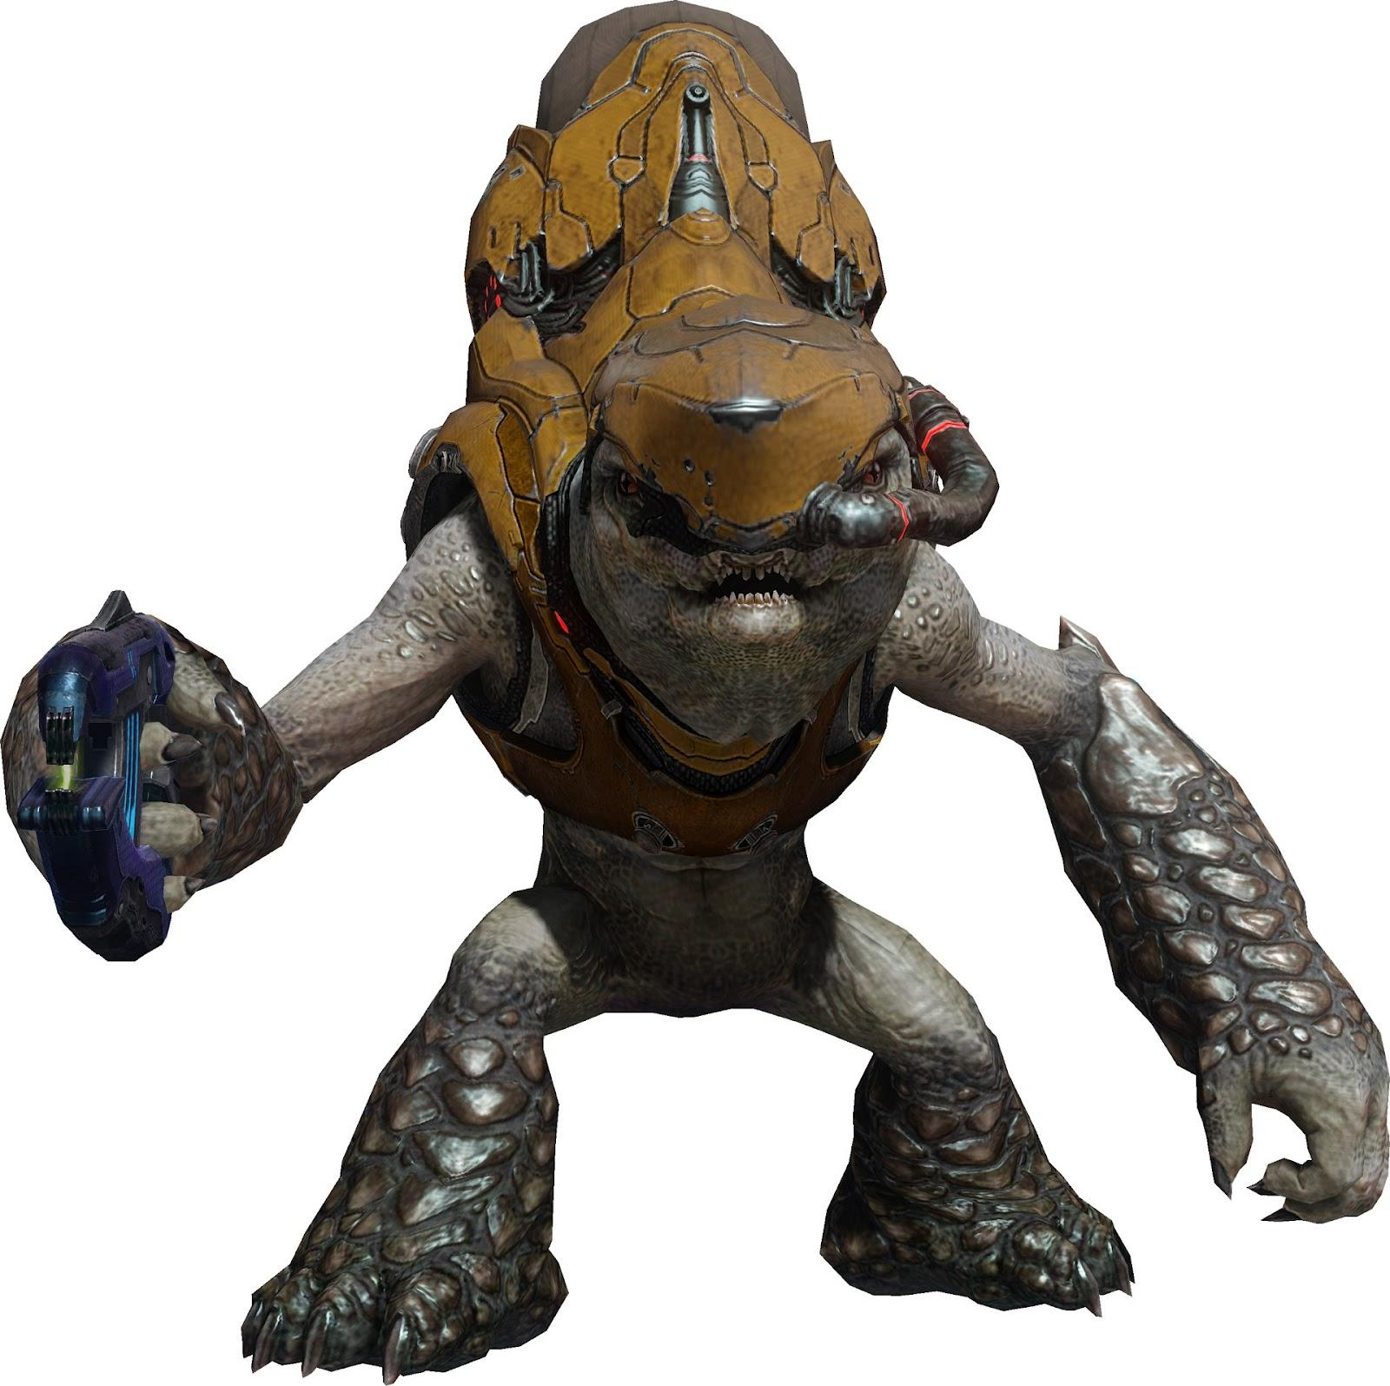

Humans: Humans in space -suits/sci-fi armor. At this point in the world, space suits are easy to maneuver in, and humans should be able to move naturally. Be sure to not go too futuristic with humans, to keep them distinguishable from robots.

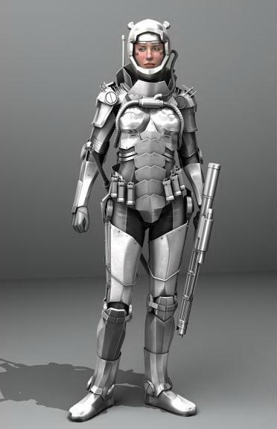

Robots: Robots, maybe in black or red to clearly distinguish them from the environment and other characters. Animations would be less “fluid” to appear more mechanical; robots would be able to move in ways that humans would not.

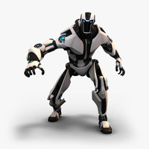

**Buildings:-**

As with units, color accents denote ownership of buildings. Nearly all buildings should be large, relative to the units, to give off an imposing feeling. Features of the building should communicate its function.

*Base:* The largest structure on the map.

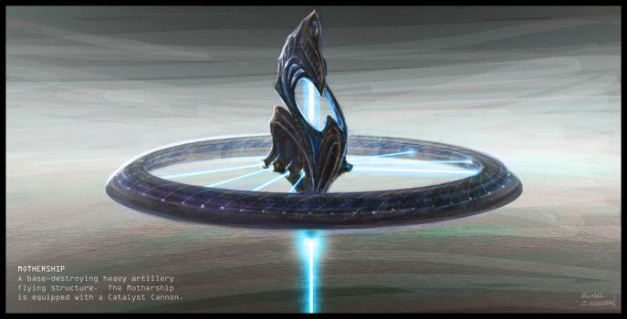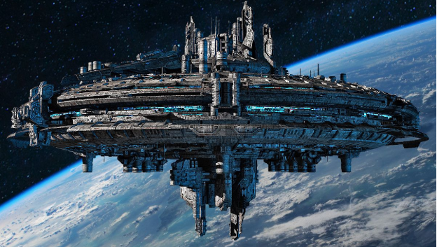

*Regeneration Tower*: Has a protection dome around it while it’s generating energy.

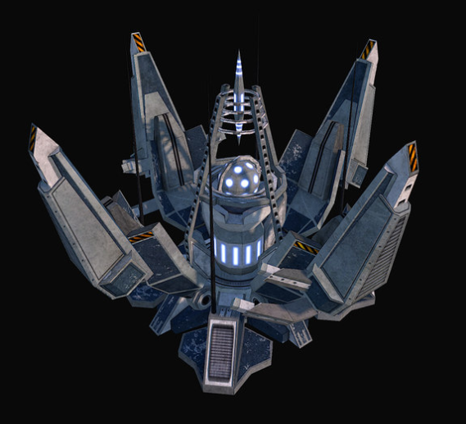

*Attack Tower:* Fires at a steady rate.

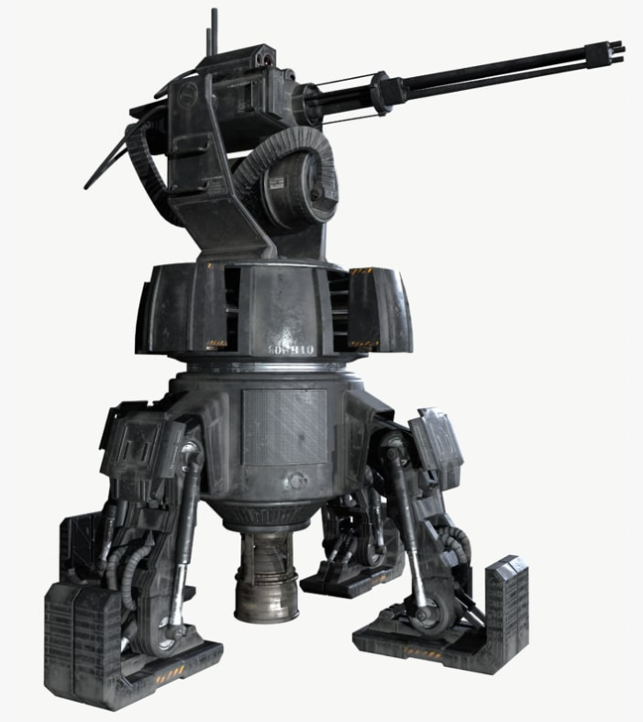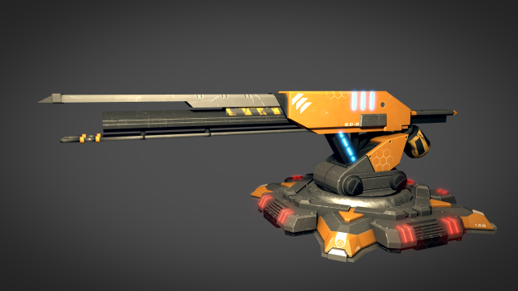

**Environments:-**

The environment can be any biome, with futuristic elements. We can stage the battle in the middle of the forest, at a major city, or even at sea. Only certain elements of the environments need to be consistent, like the appearance of modern technology embedded in the environment, and lanes running through the map.

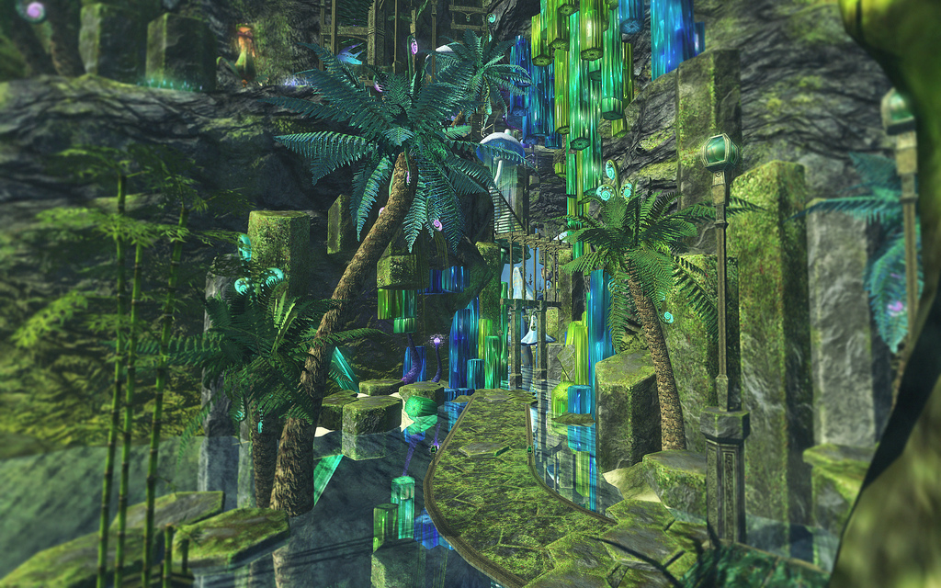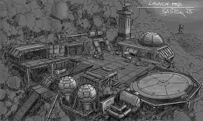

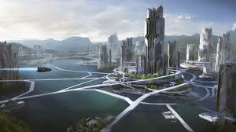

**Weapons:-**

* Melee
  + Used by basic minions
  + The melee weapons’ color and style are determined by the faction that the unit belongs to
  + 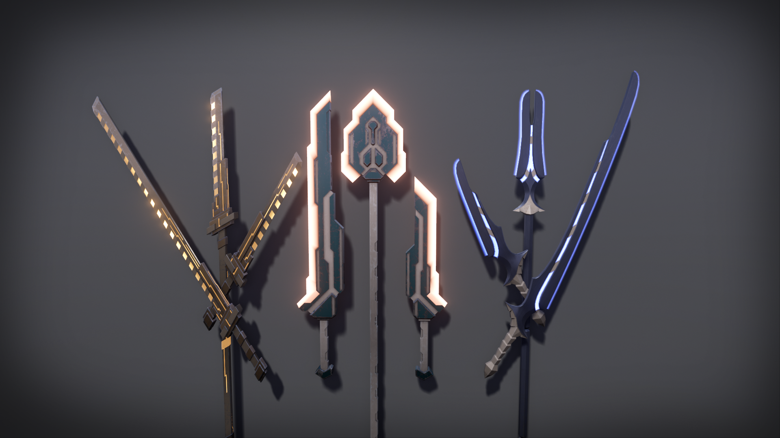
* Ranged
  + Used by advanced minions
  + The ranged weapons’ color are determined by the faction the unit belongs to
  + 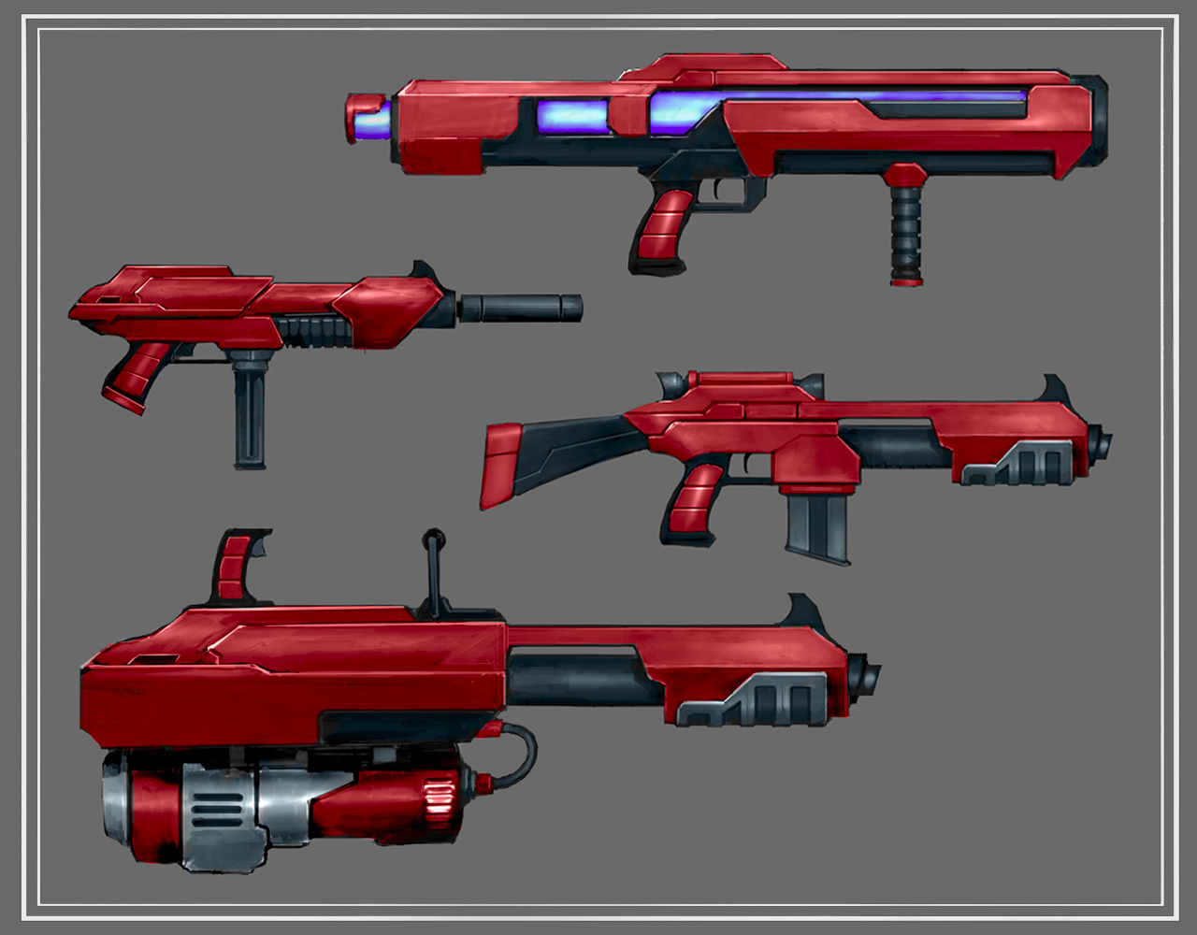

**UI:-**

* Menus should have a sci-fi look and feel by default
  + Clean, futuristic surfaces
* Non-cluttered UI in game; cards should be kept away from the action
* Example

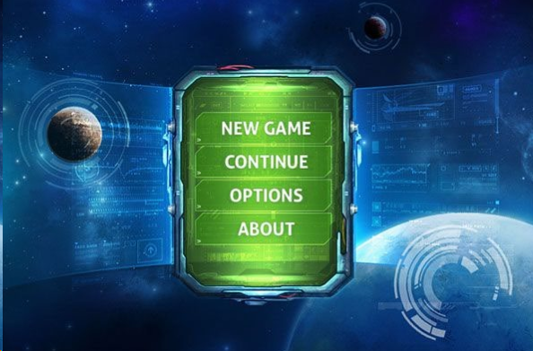

* During gameplay

The UI should be horizontally displayed during the demonstration, instead of the original vertical orientation:

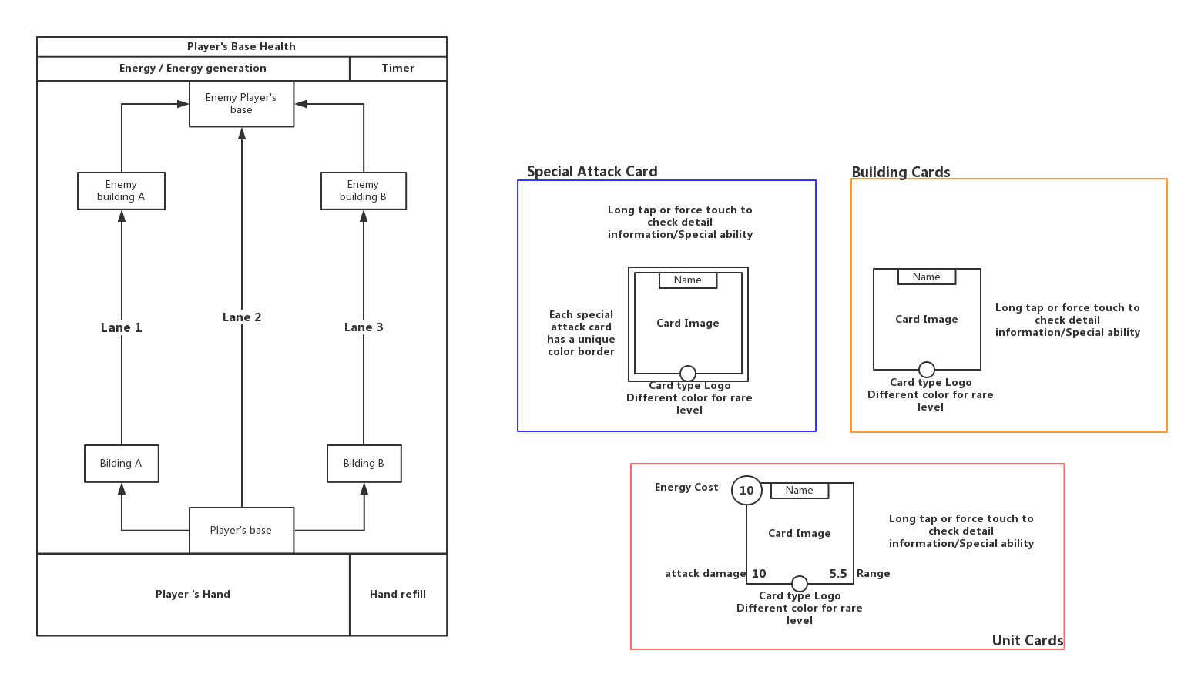

**Other gameplay elements :**

* Intensive, metallic, and futuristic feeling sound design.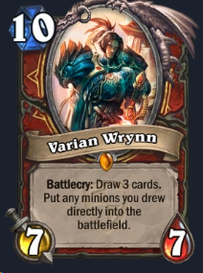

**Cards:**

* Quickly recognizable by image on the front of the card
* Important information about cards is instantly readable/understandable
* Depending on which faction the card belongs to, the frame would look different (as in class-specific cards in hearthstone)
* Images for each card should fit the style guide for the faction it belongs to
* An indicator for card rarities should be included
* Minimize amount of text on the cards

**Summary:**

Make all units, buildings, & UI elements in keeping with a serious sci-fi theme.